**Worksheet 2.1**

**Student Name:** Vivek Kumar **UID:** 21BCS8129

**Branch:** BE-CSE (LEET) **Section/Group:** ON20BCS-809/A

**Semester:** 4th Sem **Date of Performance:** 22/03/2022

**Subject Name:** MPI Lab **Subject Code:** 22E-20CSP-253

**1. Aim/Overview of the practical:**

1. 1's complement of 8-bit number.
2. 2's complement of 8-bit number.

**2. Task to be done:**

Write a 8085 Microprocessor program to find the 1’s and 2’s Complement of 8-bit number.

**3. Apparatus/Simulator used (For applied/experimental sciences/materials-based labs):**

1. 8085 Jubin simulator version 2 (Microprocessor Simulator)
2. Java (jdk/ jre1.8.0_321)

**4. Algorithm/Flowchart (For programming-based labs):**

**Algorithm to find the 1’s and 2’s complement of 8-bit number:**

1. Load the number from memory location 2000 to accumulator.
2. Calculate the 1’s complement using CMA. This will store the calculated 1’s complement into the accumulator.
3. Store the 1’s complement value in to the 2001 memory location.
4. To find the 2’s complement adds immediate 01 via ADI 01 into the 1’s complemented value which is stored in accumulator.
5. Store the 2’s complement value at the 2002 memory location.
6. End the execution using HLT

**5. Description/ Code:**

**Program to find 1’s and 2’s complement of 8-bit number:**

# ORG 1000H

LDA 2000

CMA

STA 2001

ADI 01

STA 2002

HLT

# ORG 2000H

# DB 55

**6. Result/Output/Writing Summary:**

**1’s Complement:**

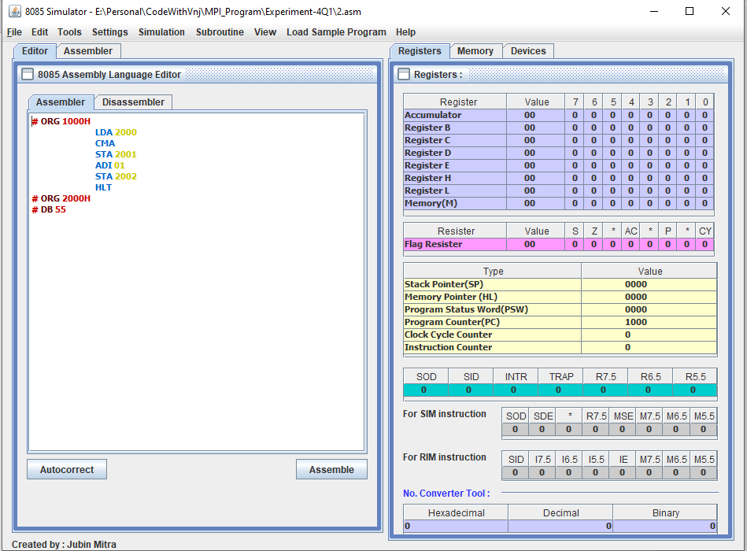

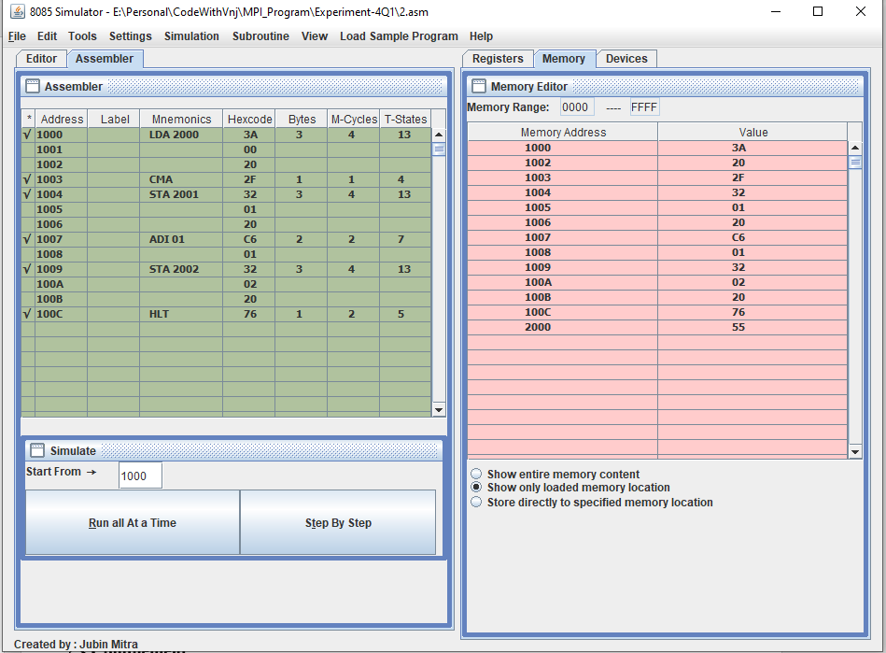

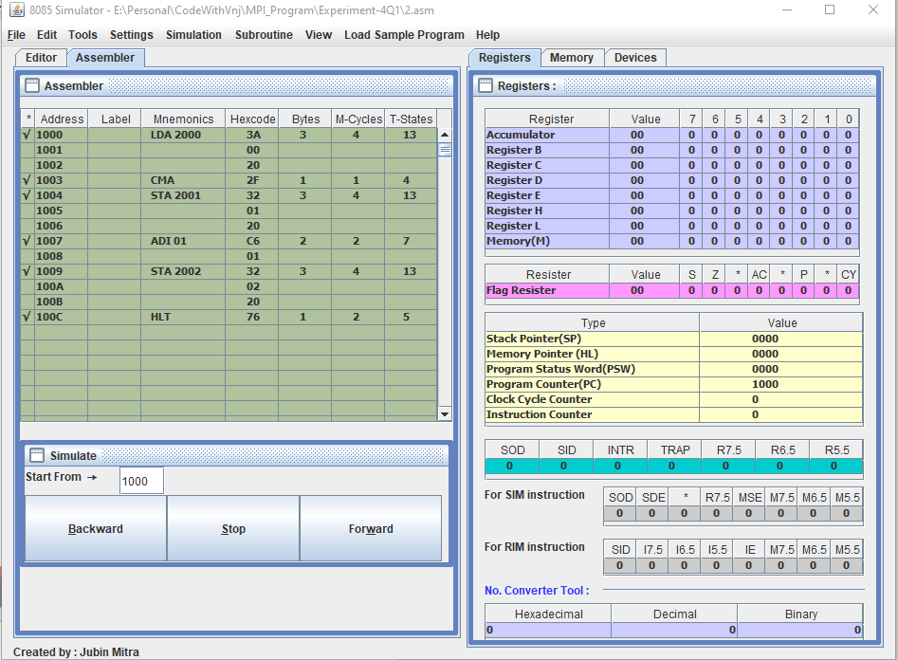

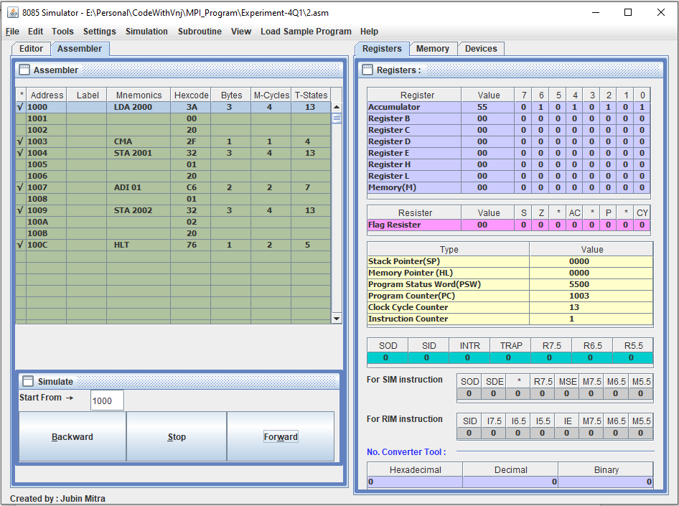

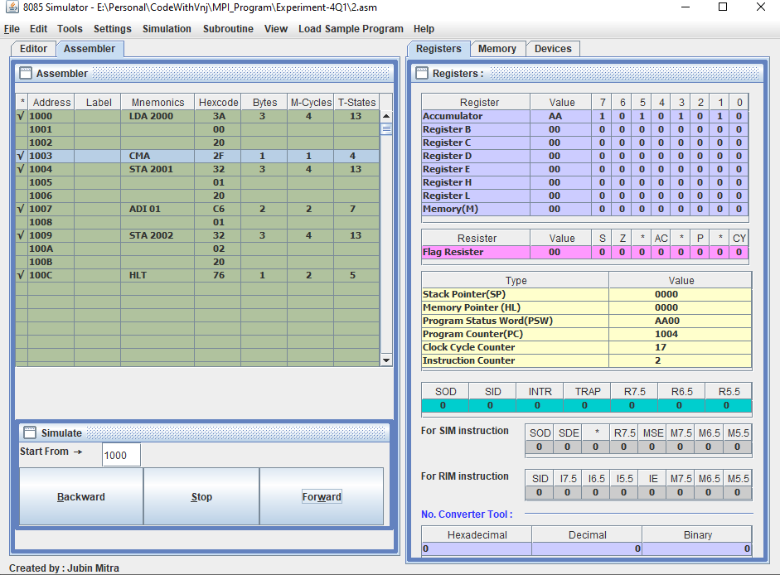

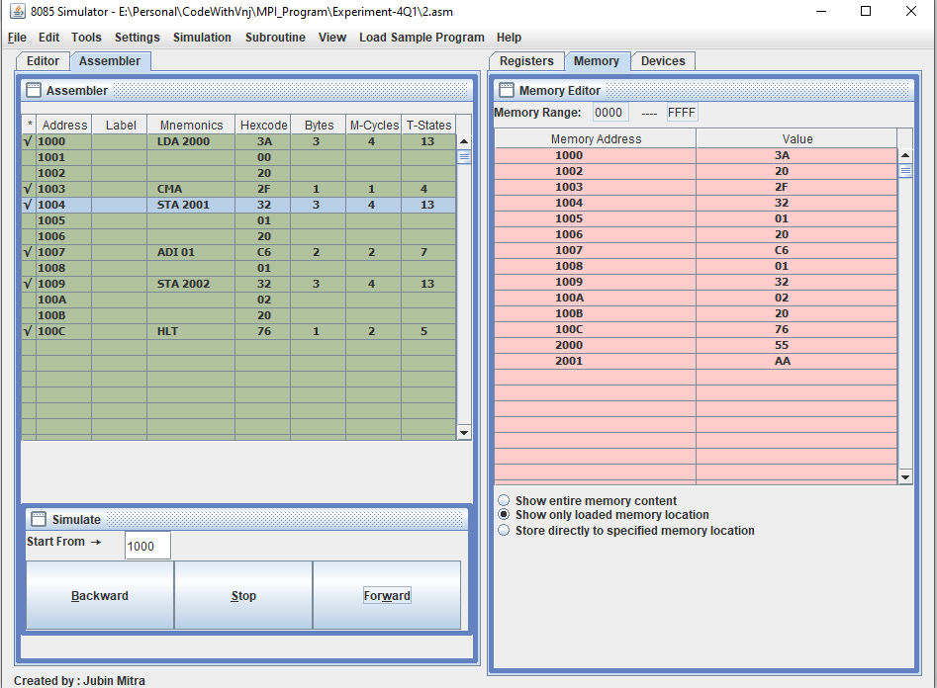

**2’s Complement:**

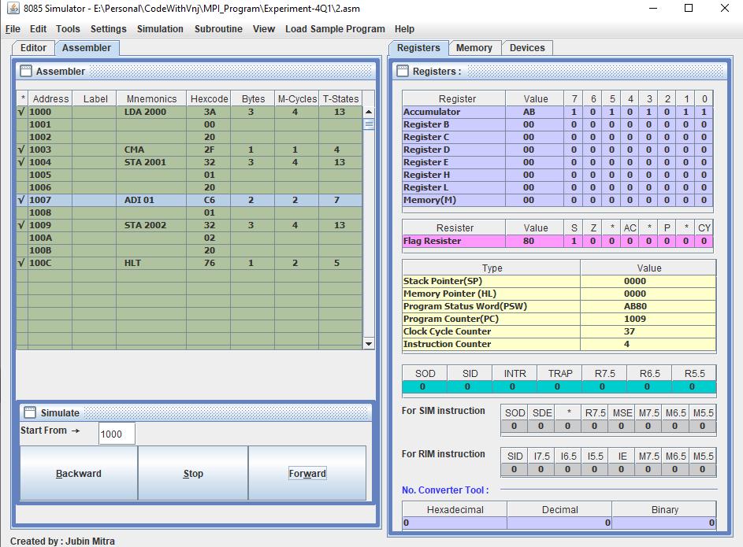

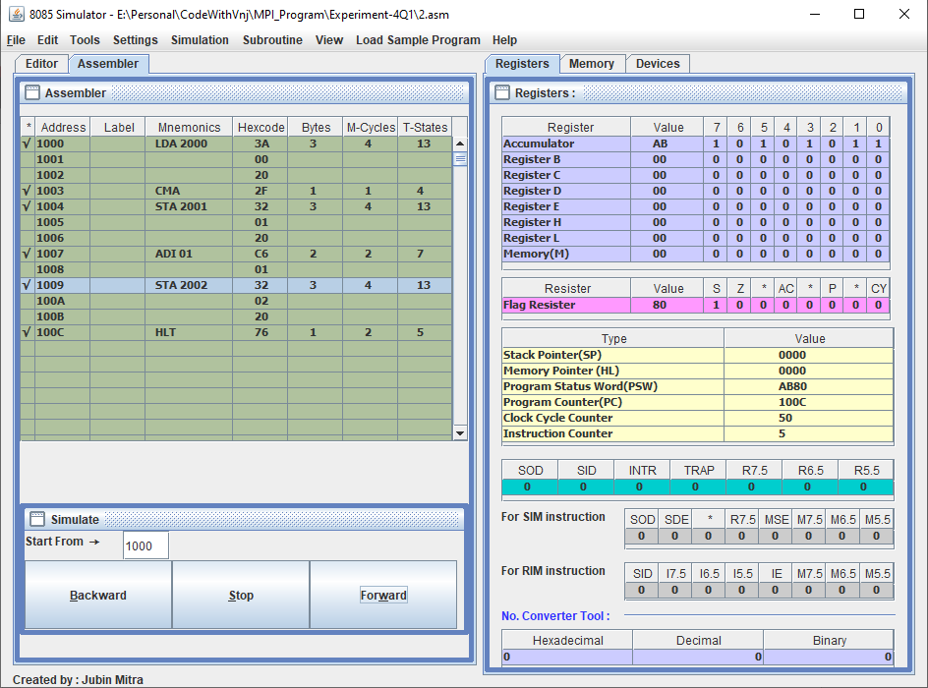

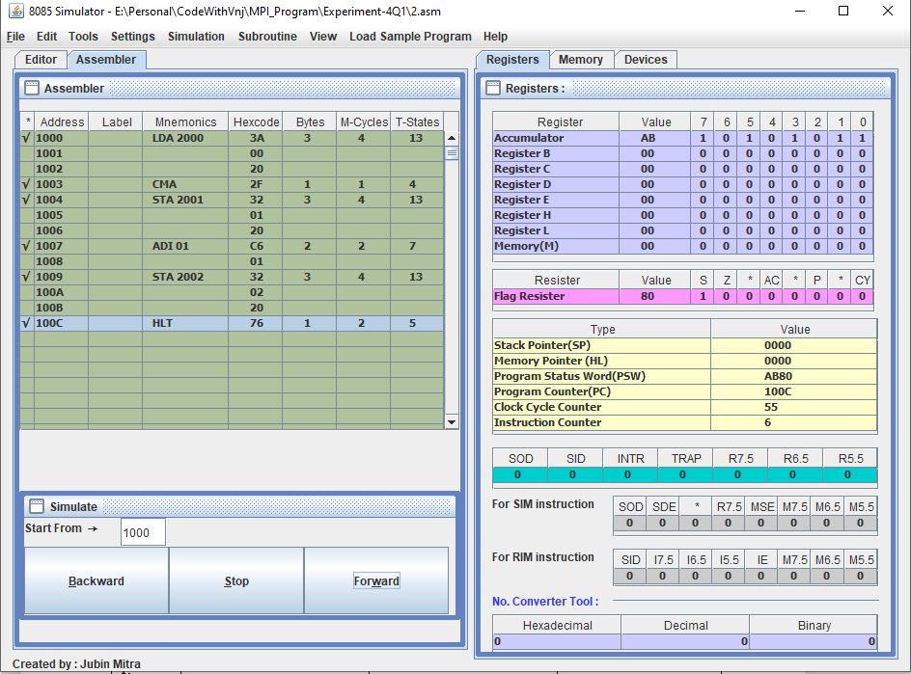

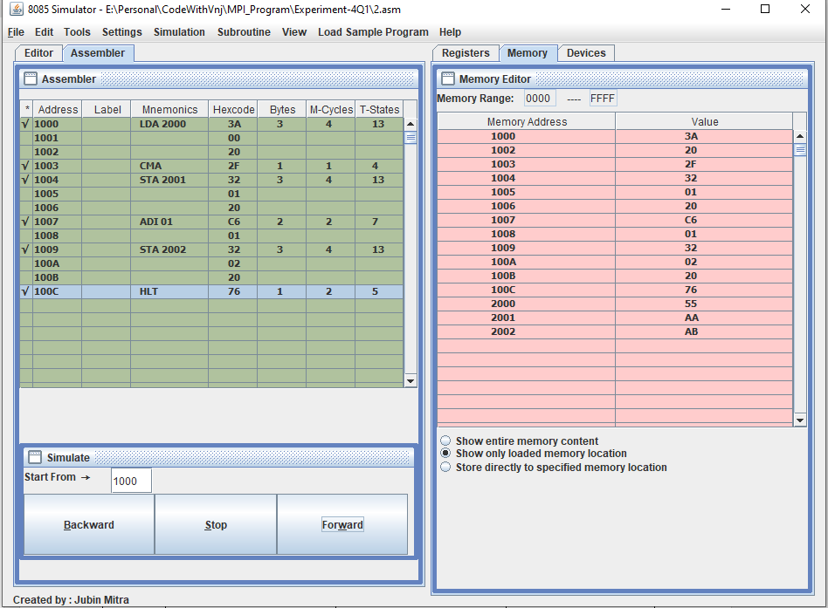

**Learning outcomes (What I have learnt):**

1. Learnt to find the 1’s complement of 8-bit number.
2. Learn to find the 2’s complement if the number.

**Evaluation Grid (To be created as per the SOP and Assessment guidelines by the faculty):**

|  |  |  |  |
| --- | --- | --- | --- |
| Sr. No. | Parameters | Marks Obtained | Maximum Marks |
| 1. |  |  |  |
| 2. |  |  |  |
| 3. |  |  |  |
|  |  |  |  |